# Guide for individual Report

## Evalution of product and process

### Evalution Function of Product

A good product is a satisfactory product that has all the functions required by the customer and it is better to have additional functions to support those main functions to help the system operate effectively. Good experience for users. Therefore, we will also look at the website which has functions that meet the basic functions and extend the functionality from the website. The website can login, each account has a different Role and will have different interfaces and functions.



Figure 1-1: Function login

For students entering the system will see the categoriess and topics.



Figure 2-1: Category, Topic for User role Student

The most important thing is the submit section, which is full of information to help Student can observe such as:

* Topic Name: The name of the topic that Student submitted
* Submit Name: The name of the topic that Student submitted
* Status Submission: Submit's status, which helps the user to know the submission has expired or has a deadline
* Time remaining: The amount of time remaining before the submission deadline will be displayed or Time remaining will be displayed if the submission deadline is exceeded.
* File submissions For Report: This will be the place to receive the Student's articles and especially they can only submit their papers by DOC or DOCX file. In addition, if you have submitted the assignment, Student will see the submission and the name of the previous submission right next to it.
* File submissions (For Image): If there are images in the document but too blurry, the Student will submit a separate image in this section.

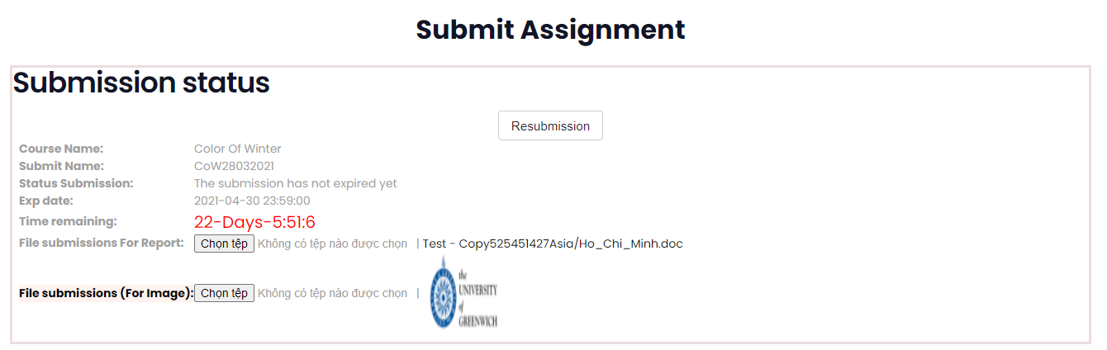

Figure 2-2: Function Submit Document for User role Student

In addition, when students submit their documents to the system, the system will open a Chat window so they can communicate directly with their examiners. This is an extended function that helps the User role Student and Coordinator to solve the problem or communicate faster with each other.



Gif 3-1: Function Chat Student with Coordinator

The system also reports the error very accurately, helping users understand why the system is not working as expected. In case the user submits the deadline, the system will issue an error "Deadline for Submission"

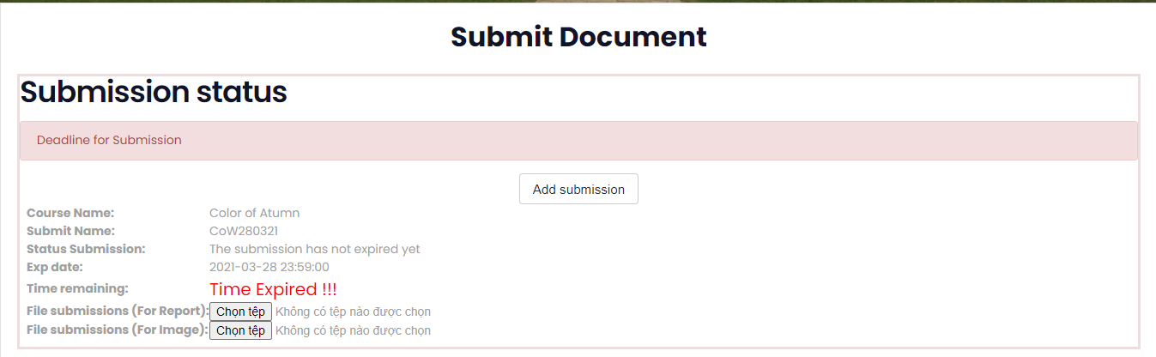

Figure 3-1: Notification Error 1

Users are also only allowed to send DOC, DOCX files for documents and JPG, PNG for images.

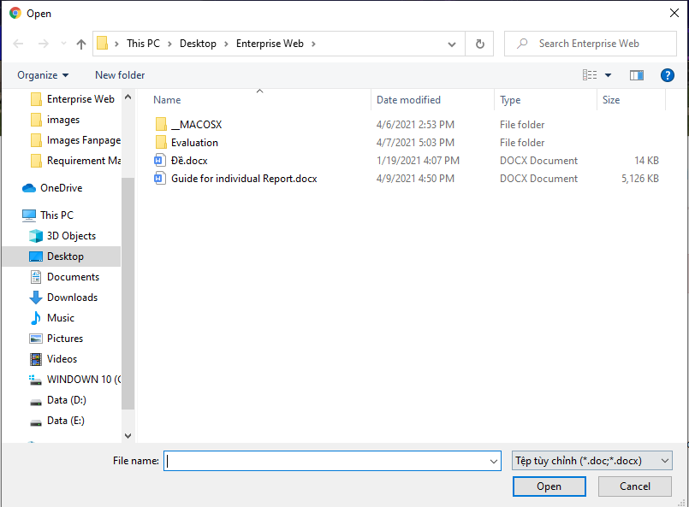

Figure 4-1: Choose Document File

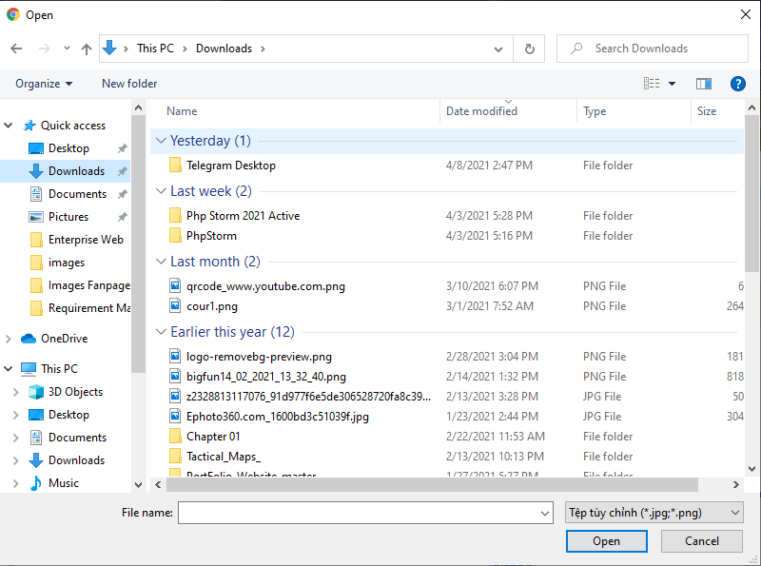

Figure 4-2: Choose Image File

We have also guarded in case the user intentionally sent the wrong file and they will receive the message "The submission file must be a file of type: docx, doc"

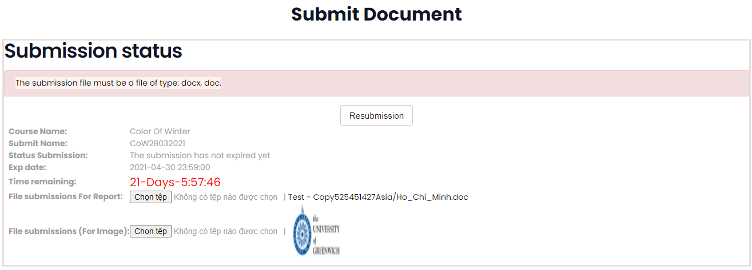

Figure 5-1: Notification Error 2

In the request of the customer, they only asked to send files to the system but did not say that we need to control the file and force the template to make the system easy to control the user, we expanded the functionality. this same error system. This makes the user experience easier and the system is controlled better, so this is one of the appropriate extensions that best promote the efficiency of the system.

As for Role Coordinator, when entering the Category and Topic they choose, all the articles that the User Role Student submitted in the Topic will appear fully including the article title, the sort order will be according to the latest posts submitted. so that the Coordinator can easily observe. In addition, the system will also have many functions to assist Coordinator in marking, we will take attendance through those functions.

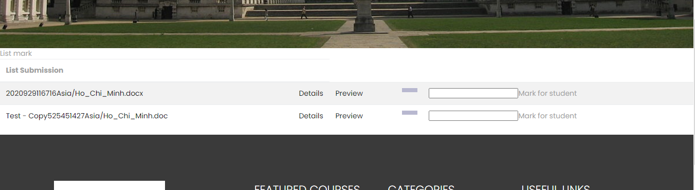

Figure 3-2: Function view List Document from User role Student for User role Coordinator

Coming to the first function will be Details, which shows all information of the Document such as File Document, File Image (if any), Name Submit, Student role name and can be scored or adjusted directly here. . In addition, will display a chat box for the Coordinator so that they can easily communicate with Student. For requirements, the approval of the post also means that the post has been selected, but we also want to expand in the grading system to have a clearer competition in evaluating documents for the main Student Therefore, the system will have an additional scoring function.

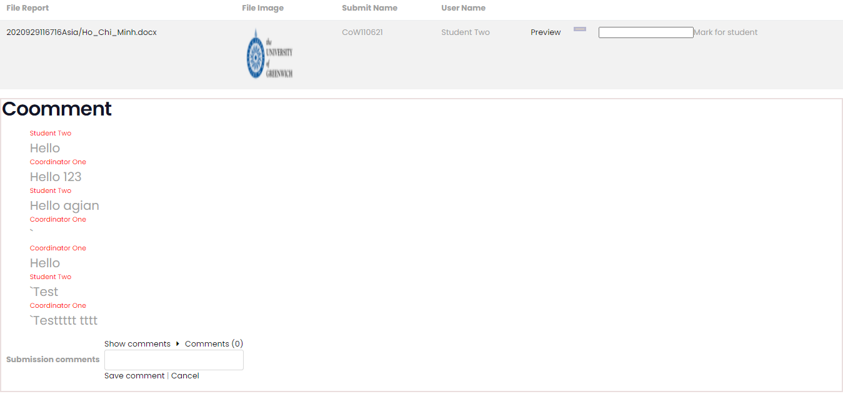

Figure 4-1: Details Document from User role Student for Coordinator

As for the Preview, the window will open for the Coordinator in a window displaying a Document so they can immediately read the article online and possibly be edited if the post is Approve (this will depend on the Document. and Coordinator), we want to create flexibility for the Coordinator in the most effective way.

For this part, although there are many differences compared to requirements, it still satisfies customers' requirements. They want the Coordinator to see the Document, then can download and view and decide which post Approve, but we guard in case there are too many Approve Documents, which is the best post based on the evaluation of Coordinator so we added their grading to help the system solve the problem of clear grading data. This is a good extension of the group I use for the product to help users have a good experience when using our website product.



Figure 4-2: Function preview document for User Coordinator

Next is the User with the Manager role, this is a User that can add all the Documents and details of that Document like (....). We have followed closely the topic and completed the Manager exactly as required.



Figure 5-1: Function preview document for User Manager

Finally, the Guest, they can only view the Approve articles and cannot download them or copy anything from these Documents. We also follow the requirements for this User role Guest functionality.



Figure 5-2: Function preview document for User Manager

Our products are created to be a good website because it has met the features to meet the requirements of the customer and expanded a number of support features to help the system be flexible and highly interactive with users. Although the system is still more erroneous, as it has not fully improved the Front-end so that the website can be easy to use and look beautiful, the functions are easy to use, tested and corrected many times to limit the experience. of the user. To do that, we have used the SCRUM model in the team to be able to work easily, adapting to changes if any. We divide the work into 3 prints with 1 print is 2 weeks and we have a total of 6 weeks to complete the project. Use Trello for easy Backlog listing, handling and control.

Finally, a very special role for the User of that website is the Admin. This is the User can control the website so they will have a completely different user interface to create good security for the website.

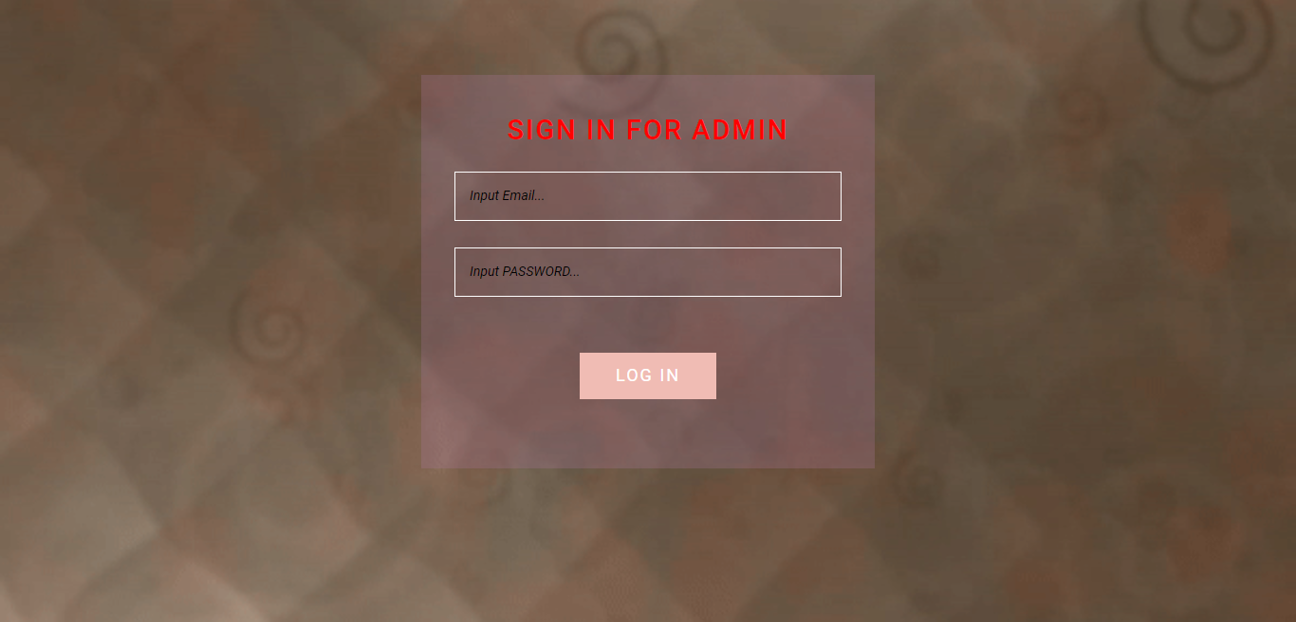

Figure 5-3: Function login for User role Admin

Here, Admin can manage all Categories, Topic, Submit and User. They can create, view the list, edit or delete them at will.

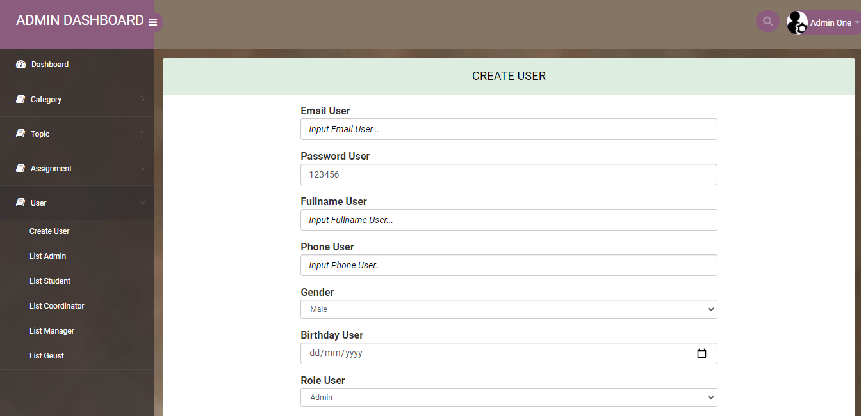

Figure 6-1: All Function of Admin

We have fulfilled all of the customer requirements for the User role Admin with many extensions such as giving them a separate page for increased security, an easy-to-use interface, and display of specific functionality. I can judge that the product in this category does a very good job with the necessary expansion that is responsive to the user.

Considering the overview of the user's requirements for the function, I think that the Group's products have done very well and have the appropriate extension functions to help the website work better and bring an effective experience. for users. For general premises and customer requirements, we did better than what customers expected.

### Evalution Design of Product

For user interface design, because we did not have much time, we did not optimize all the website, the product was only acceptable and usable. We have Header, footer going through the website to make users feel comfortable, easy to use and familiar.



Figure 6-1: Header of Website

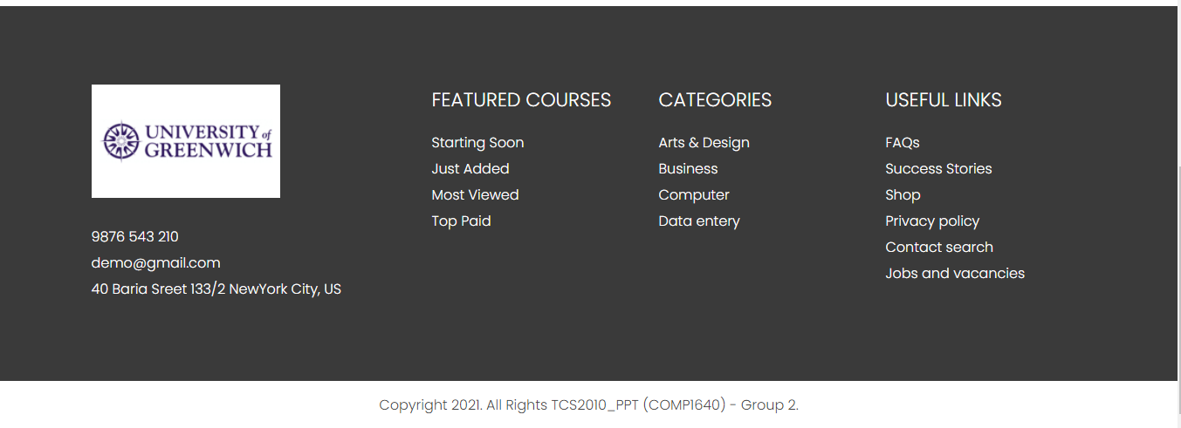

Figure 6-2: Footer of Website

We also do the right thing with a basic website, normally that opening a website will be for the user to know the website's organization overview and what it is set for. We have designed the Home page as the starting page of the website and all of that information will show up here from the organization's introduction (Greenwich), Topic topics, the organization's success history and so on. on. The information is very short and designed to be planted on top of each other so that it is easy to observe, but does not cause discomfort when experiencing. We have researched on websites with similar content and are rated by some users so we think our website may be done well in this category.



Figure 6-3: Home layout website

Because we want to save time, we only aim at simple but effective designs, so the design of Category, Topic interfaces will be very clumsy for all Users. This can also create a user consistency that is easy to interact with. In terms of reviews, this may be a minus point because the website does not have many effects to help users feel comfortable when using. The website just stops at completing its task of showing users what they will use and not doing more than that.



Figure 7-1: Layout for Category and Topic

Considering the website overview, I self-evaluate in my opinion, the entire Group's product interface has not met expectations when it can surprise or enjoy using it. All interfaces are only displayed at the correct and complete level of necessary information as requested by the users.

Regarding the phone user interface, we have optimized and adjusted accordingly as all users may be confused to meet customer requests. We will go through the main pages that users will use a lot in the process of using our website products. The first can be said to be the homepage of the website, where most of the users use it.



Figure 9-1: Layout Home page on Mobile

Not only the main page, but the rest of the pages have also done a great job in this area for mobile users to manipulate. Especially the page that the administrator of the website can use, the Admin role object. We understand that, administrators need to use the website anywhere so a phone is always next to it is better than a bulky laptop, so we have optimized the website appropriately when used by Admin. From login page to inside interface page.

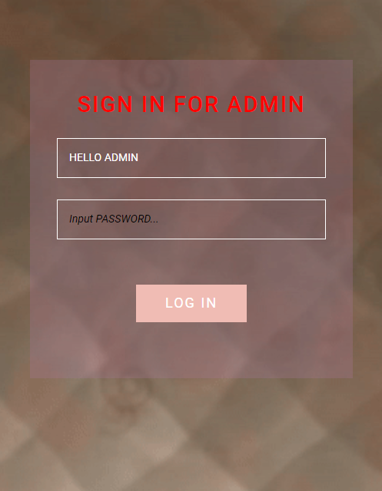

Figure 10-1: Layout login admin page on Mobile

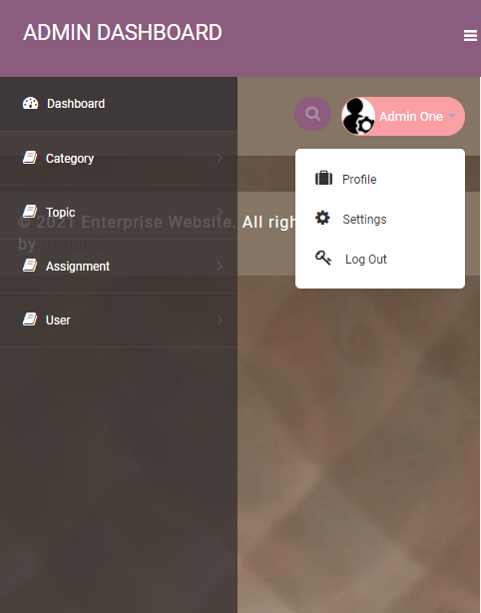

Figure 11-1: Layout admin page with mobile

I can judge for myself that my team's products have done well to satisfy requirements for website users by mobile devices will always be comfortable and experience the best. The alignment and layout will not cause the background frames, text and so on to overlap, and the balance ratio is also stable, making it easy for the user to use and adapt.

### Evalution process of Product

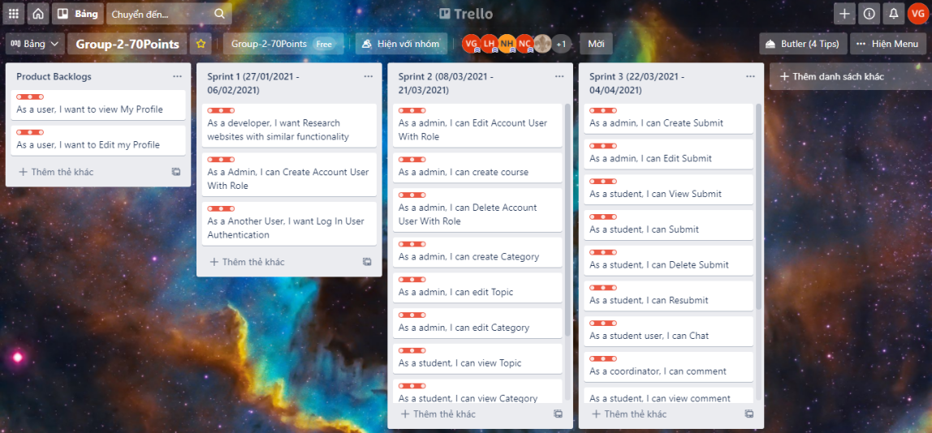

Figure -1: Trello Of Group

For the joint work and problem solving we go to Facebook Messenger for a few notes or talk. In addition, there will still be a meeting on Discord every day to set out the issues to be resolved during the day or maybe the problem was not resolved yesterday. Also in this Scrum model, we can solve problems quickly such as realizing that a team member is too weak in programming language skills and feeling that the whole team has not adapted to the project well. to be able to give the right direction and correct mistakes as quickly as possible. Although each person is assigned a different job, but the general purpose when using Scrum, we still find a link to accomplish the common goal such as the Tester can test the functions of the system after setting up. Completed backend submission. We have handled the project well under the Scrum model because the links work in parallel but support each other starting from the position of Leader recognizing each person's forte and dividing the work properly, the process begins. It is also clear that when the person responsible for writing the report will summarize the report for everyone, then the person in charge of digram drawing will work with the developer to build the sample diagram system on the previously written reports, the tester will undertake the last work on the chain and then back to the reporter.

## Evaluation of a Team by a Team

Working in a group means having many individuals, so I am always aware that I have to work purposefully and follow the pace of the group, so the most important thing is to immerse yourself as a group in it. To do this I take advantage of several ways to do it.

* I have created and maintained an atmosphere of trust and open, honest communication. Everyone is always sociable, happily communicating with each other and especially everyone in the group is open to their jobs, this helps the group to be stable because individuals who do little or delay will other individuals reviews. At the same time, these will keep every individual in the group to always have a sense of self-awareness with the responsibilities they are doing, which is something a leader like me is also pleased to be able to control all assigned tasks. everyone is not late.
* Next, making use of the resources and talents of all group members is a very necessary thing. The members of each group each have a strength and most of all, they cannot complete the project on time without working together, thus making use of the resources and talents of the whole group together, together. sharing, helping with work will help the group speed up the progress and get a good product.
* Finally, sharing skills and knowledge and encouraging learning from each other will both help group members get along and be friendly with each other and help them improve their skills well. than. This indirectly as well as directly helps the product to be completed, achieving high efficiency in the process of making the product.

When interacting as a group in the working process will certainly create a lot of difficulties. Symbolic is that at the beginning, people do not trust each other much, this is a problem that takes time to solve because no one knows what problems the people in the group can solve and it is worthwhile. give trust. But fortunately through a few conversations and starting to do the first few Tasks of a project well people begin to trust each other more than at first.

Next, the low level of interaction is also a problem that occurs at the beginning, everyone in the group is used to working alone or is not used to working with some of the remaining members, the group name is also very limited. cooperation. To overcome this, I tried to adapt, create working connections so that the group members gradually adapt and interact more for the common purpose of completing work well.

In the end, not going in the same direction, just like the second problem, people are out of sync without looking in the same direction, which is to make the final product get the best results and work hard for the rest of the work. myself and this will negatively affect the group a lot. The solution is to find work cohesion of members together and correct yourself with them.

After all the process of going through the same group, there is a core problem that I think if doing this action will help the group improve a lot is that I will have a meal together to help each other open, have meetings. Initial talk is also an initial meeting to define the project's ideas and goals. What I learned is that everyone in the group must have the same thought and look in the same direction to help the project as well as the product achieve the best results.

## Evaluation of Team

For team evaluation I will have a summary sheet based on what happened in the project and analyze a specific summary below the image.

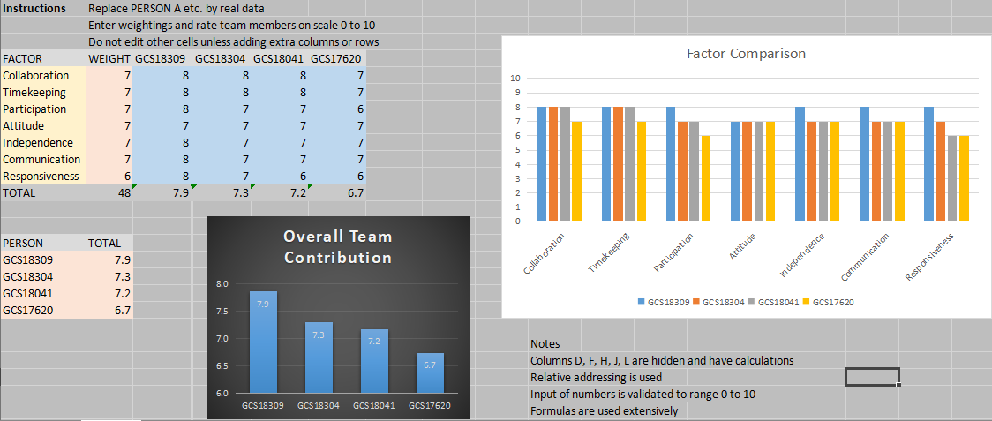

Figure -1: Evaluation of Team

I will evaluate each individual in the group according to the following criteria:

* Collaboration represents individuals interacting and coordinating with the team to develop projects.
* Timekeeping represents individual diligence
* The Participation indicates the amount of work the individual should do on the project
* Attitude points to individual enthusiasm for the project
* Independence exhibits self-resolution and separate work handling for projects
* Communication indicates individual scores for interacting with other team members
* Responsiveness shows sophistication in the situations that occur in the project

These indicators may provide an overview of the individuals for the project.

Ranking scale

I can give a scale as follows

* Excellent: The level of an individual's excellence that is beyond imagination, the level of expertise of both hard skills and soft skills far exceeds that of the team members and the common ground.
* Very Good: Well done with all the goals the group has set for an individual. There are many positive contributions that change the project in a positive direction.
* Satisfactory: Assigned and assisted and guided by other individuals but still doing well in the group. Not many positive contributions change the project in a positive direction.
* Ordinary: Delayed compared to other individuals in the group, late in appointment with assigned tasks and lack of sense of responsibility for the group.

Based on the scale as well as the rating according to the individual indicators I will make my own assessment.

* PHI VO QUANG VINH - GCS 18309: Very Good
* LE DUY KHANH - GCS18304: Very Good
* NGUYEN NHAT MINH - GCS18041: Very Good
* NGUYEN CHI CONG - GCS17620: Satisfactory

## Self-evaluation

After reviewing my product, rating my team members, I will also rate myself. To evaluate myself in the project I will rely on the following factors:

* Independence of thought and action: I am a leader of the group, I know that I understand best what the group is doing and lead the group to success so independence is very demanding. From soft skills to professional skills such as knowing clearly what each individual has advantages and disadvantages to appropriately assign work. I do a great job designing website from Front-end to Back-end without any help from other members of the group. In addition, it also helps other team members to complete their work on time.
* Creativity in approach to problem: As for approaching an issue, I feel like I did well, I understand the level and abilities of the group members and understand what they are thinking about problems. So I approach very quickly giving a reasonable solution.
* Determination and effort: Although I always have a sense of responsibility for the group, I still feel that I really haven't made a lot of determination and effort towards this project.
* Effective use of time: The project could have been completed about 2 weeks earlier than the deadline, but my own unreasonable calculation of working time did the project just before the deadline 1 week. Therefore, I think that I have not done well in handling time properly.
* Leadership: Regarding leadership, I can be completely confident because my team has a different direction from many other groups to complete the project, so many problems arise. I have helped members in addition to completing the project well, to promote all their strengths or correct the mistakes they make in the project. In addition, I also help me in training the professional skills and soft skills of the members of the group. I think I have excelled in my own leadership.
* Contribution to team effort: Although I was not determined and put in a lot of effort towards the project, my efforts with the group are above the "full shoulders" level. In addition to doing a good job assigned to give a good direction for the team, solve problems that may arise in the project and help other team members. So I feel that I'm pretty good at this factor.
* Completion of assigned or agree-upon tasks on time: I always complete the assigned work excellently.
* Participation in team meetings: I'm always there ten minutes before the meeting, whether it's offline or online.
* Quality of written contribution to team effort: The work in the group is divided very specifically, in terms of writing reports or documents, I probably did not write anything for the group, I just give comments with ideas. So this was probably not so good for my effort to contribute to the group

Going through the above general evaluation factors, I conclude that I am a responsible person for the team and do my job excellently.